1. Create Chart between Measure Names and Measure Values. Add filter to Measure Names

Output:

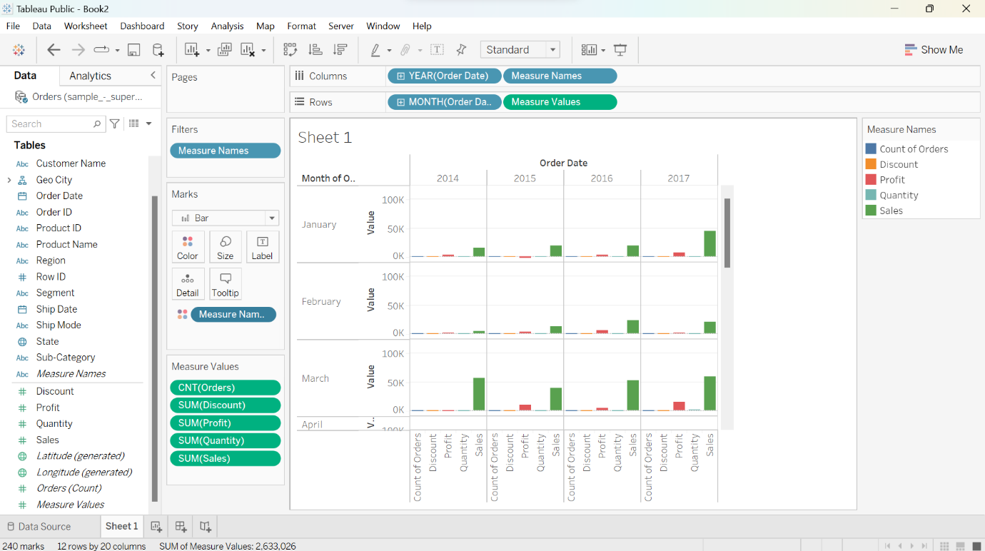

2. create a chart for the total profit on different years along with the profit earned by

Months

Output:

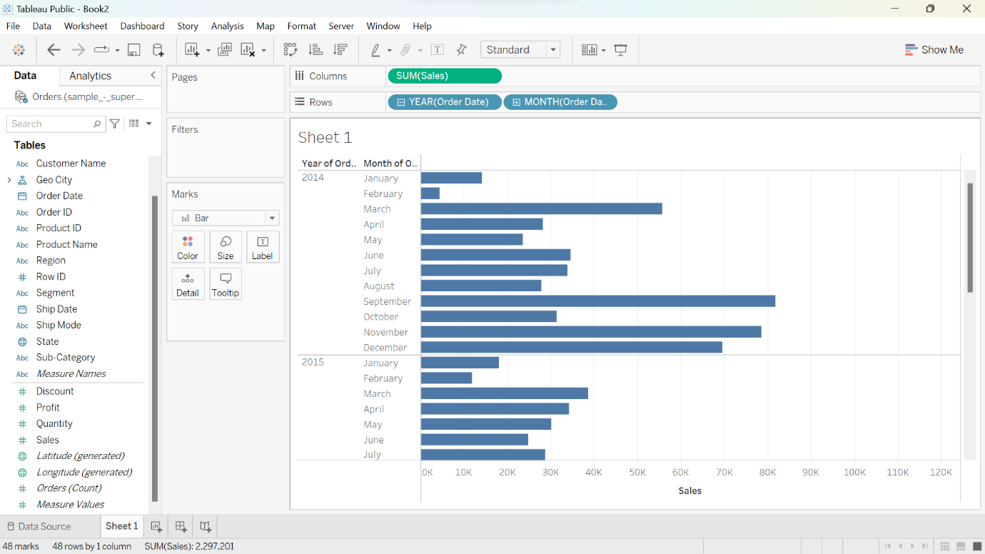

1. Create chart for the total profit on different years along with the profit earned by

months on the x-axis.

Output:

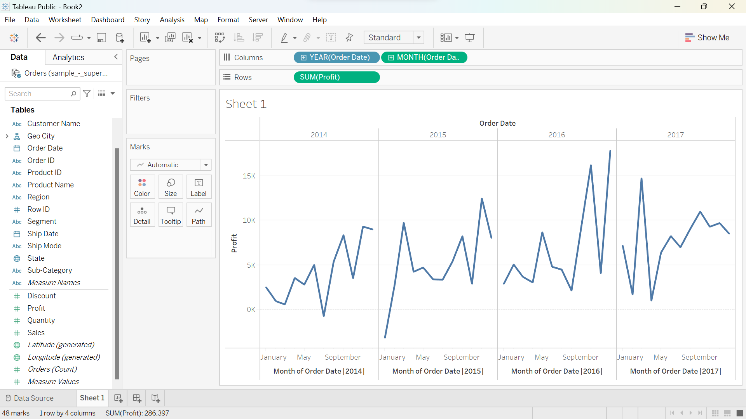

1. Create a text table for the Avg (Sales) for each subcategory using Sample Superstore?

Output:

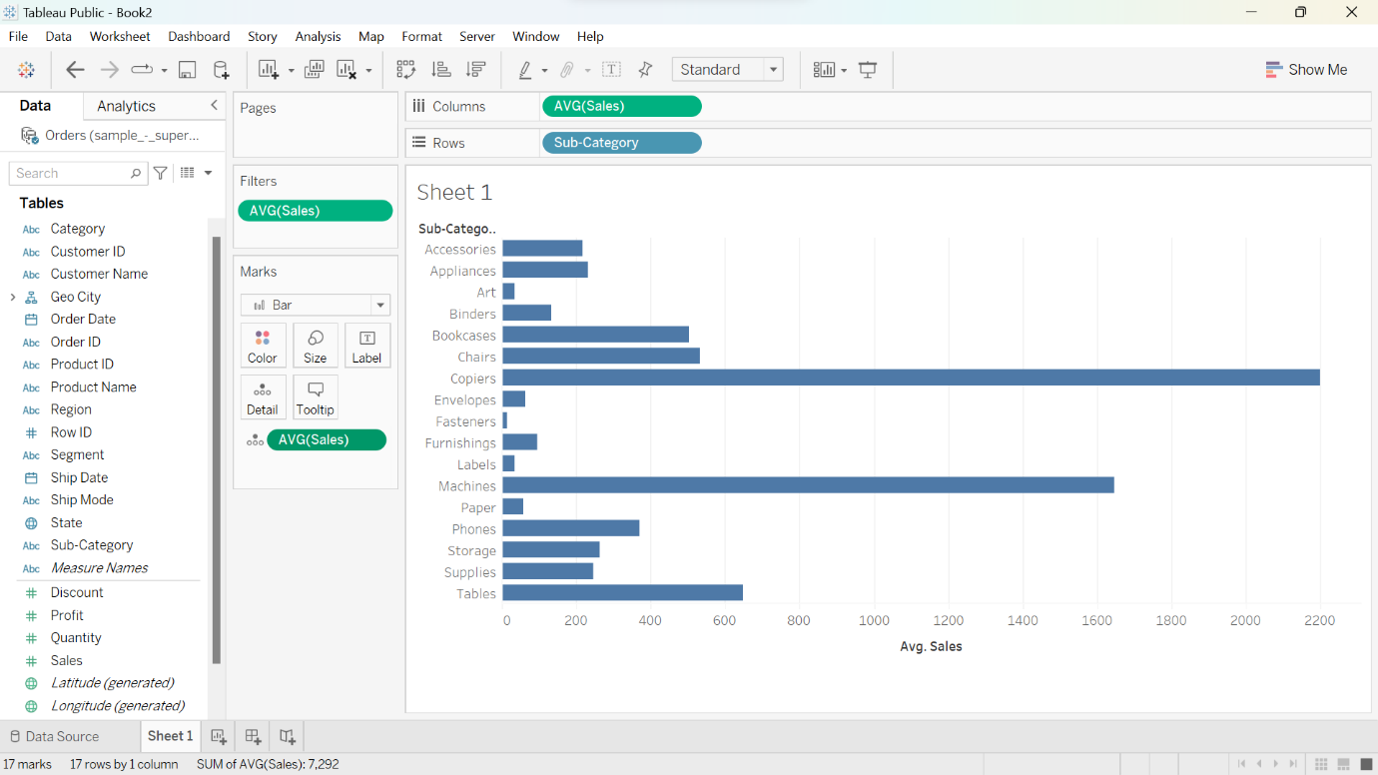

1. List which Sub Category is got Avg (Sale) more than $1000? -Sample Superstore

Output:

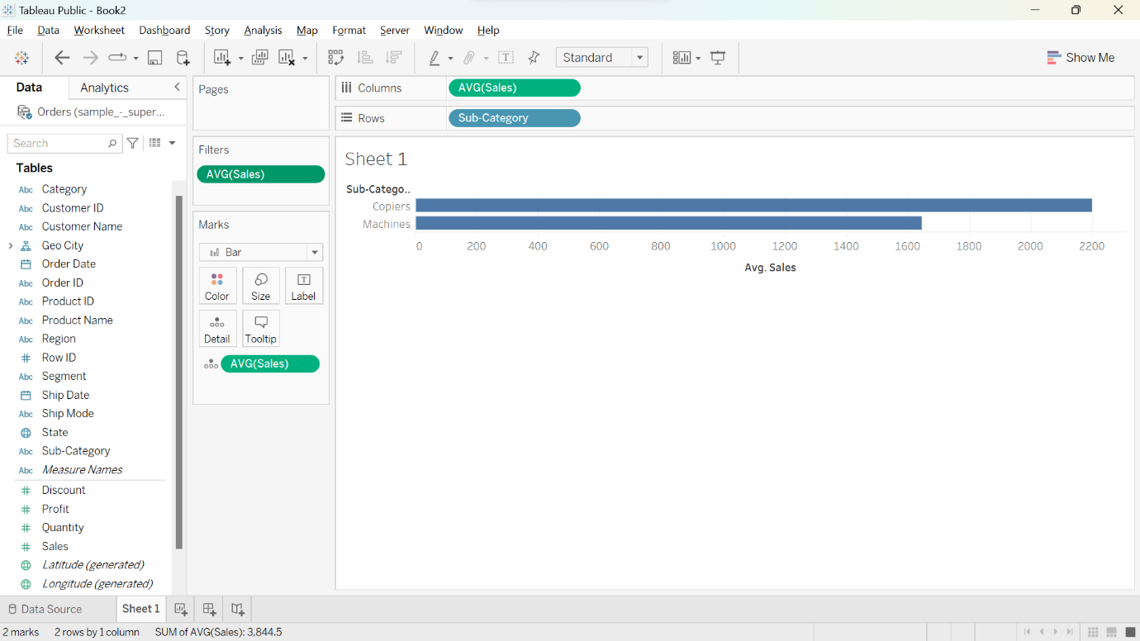

1. Create a Highlight table for the States for the Order Date Year whose highlighting is done based on Sum of profits -Sample Superstore

Output:

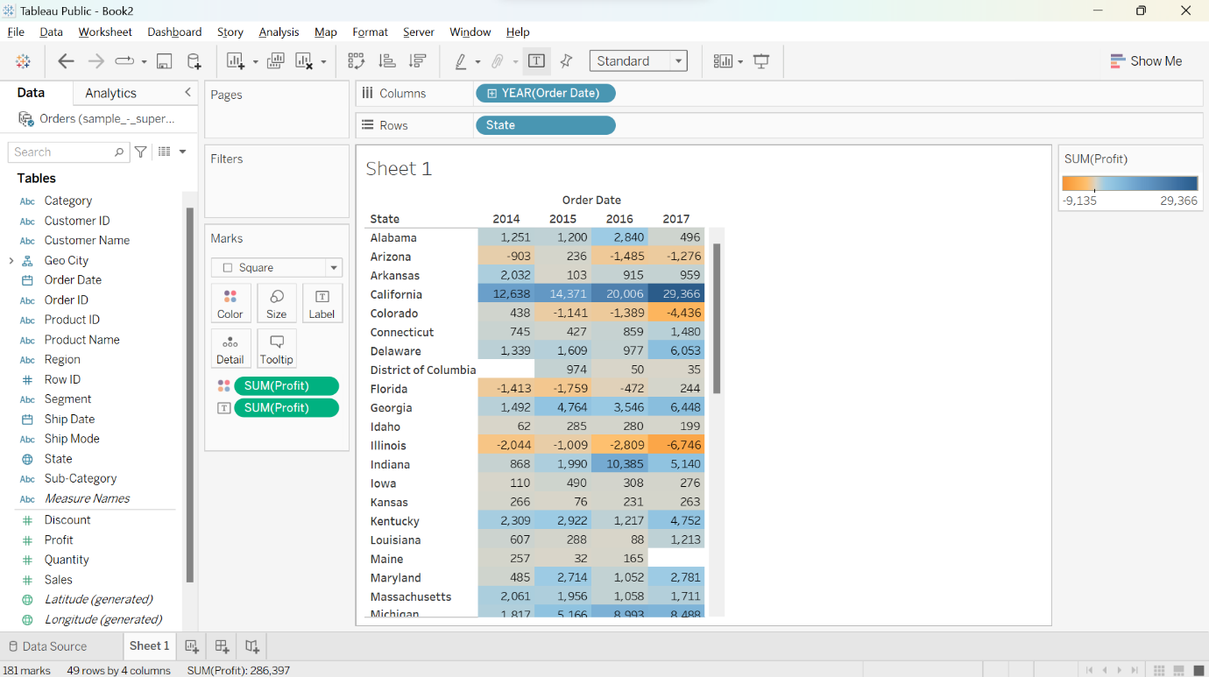

7. Which customer is having maximum returns of sales in the year 2011? -Global

Superstore

Output:

